GENERATION OF RAMP WAVE USING PROTEUS
AIM:
TO GENERATION OF RAMP WAVE USING PROTEUS
PROCEDURE:
i. Create a new project.
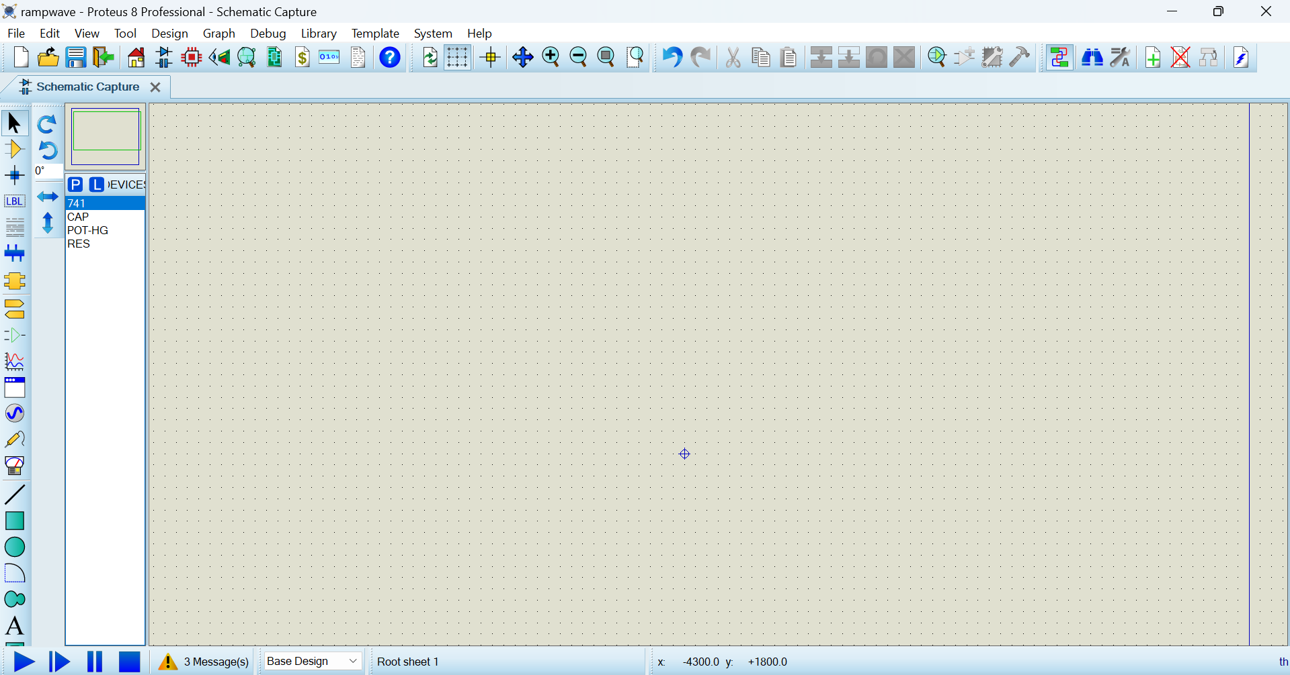
ii.Select signal generator from  and place in the chart.
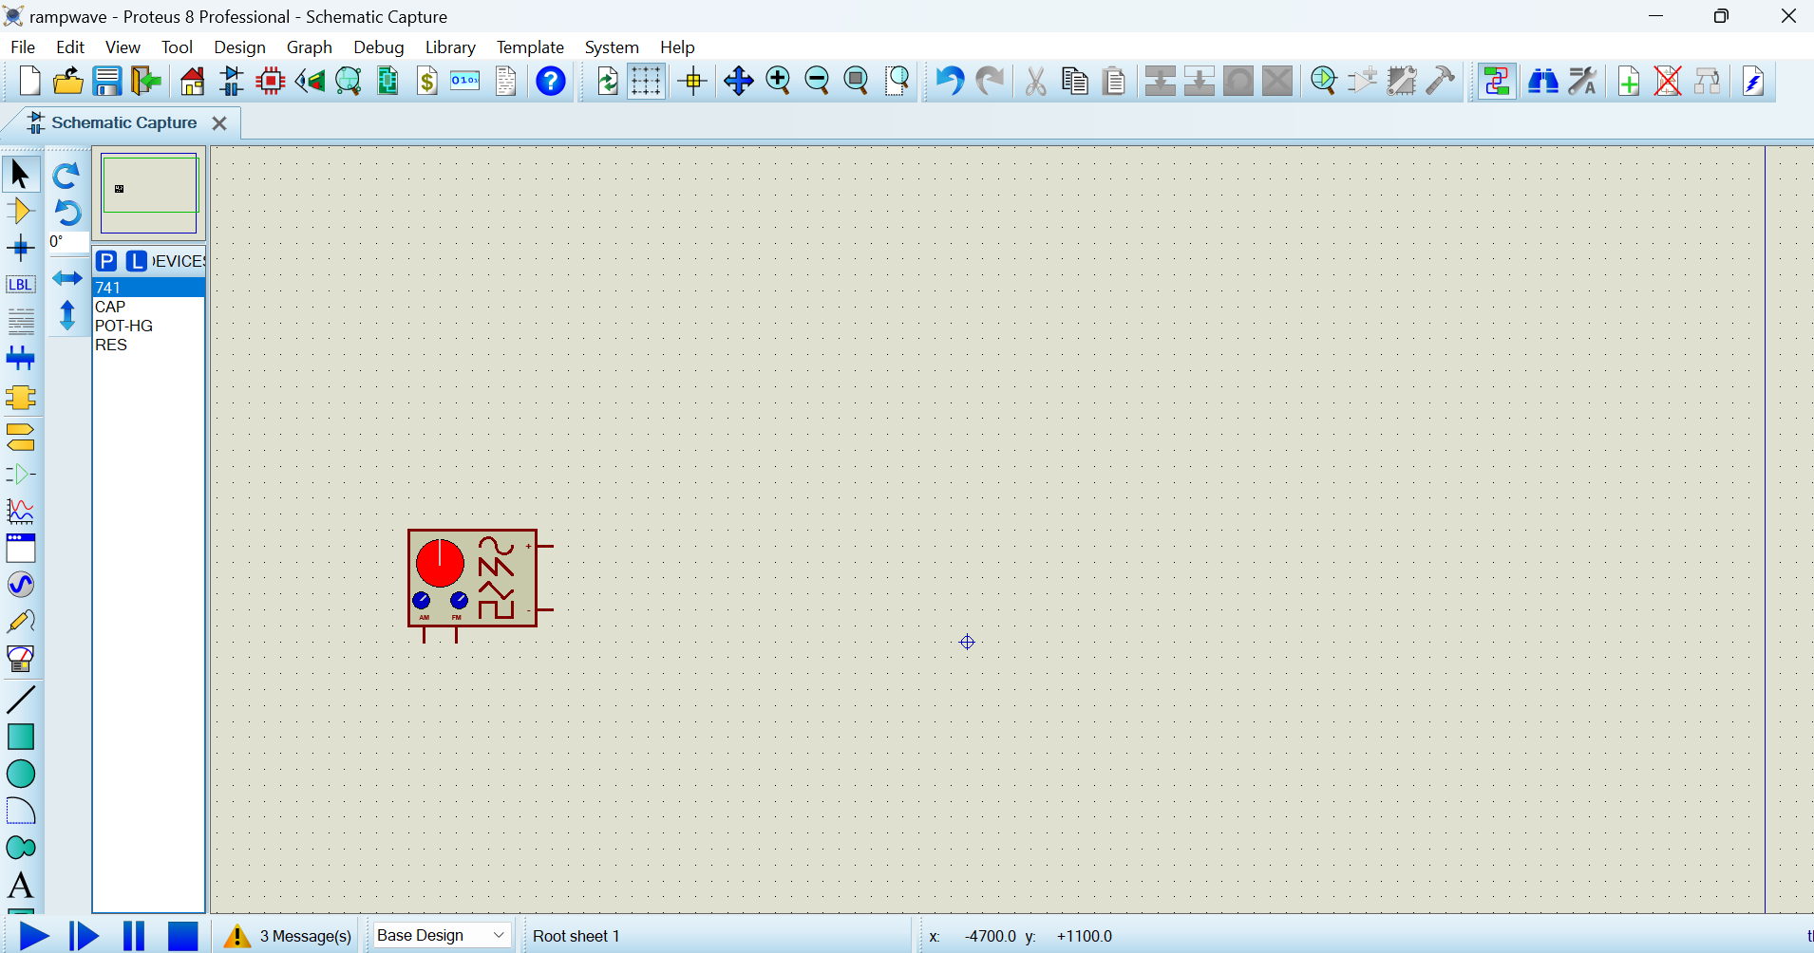

iii.select resistor (RES) from  and place & connect as shown.
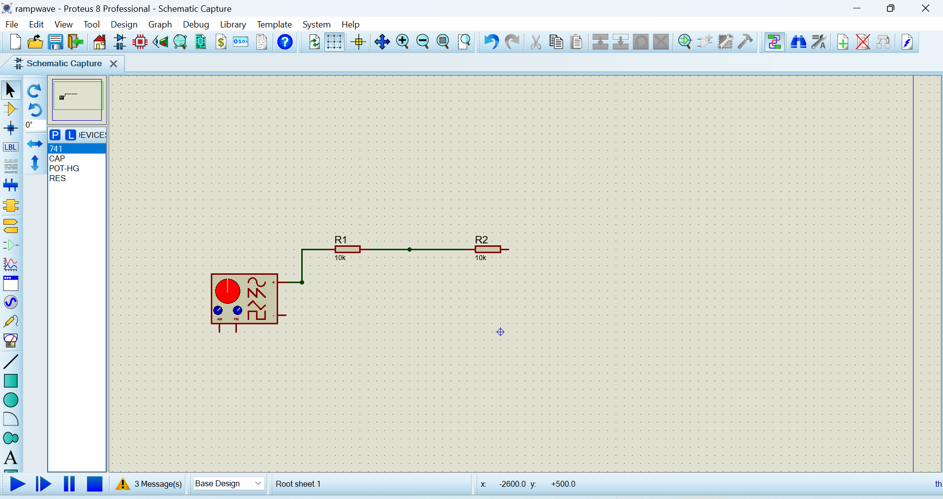
iv. select capacitor (CAP) from and place & connect as shown.
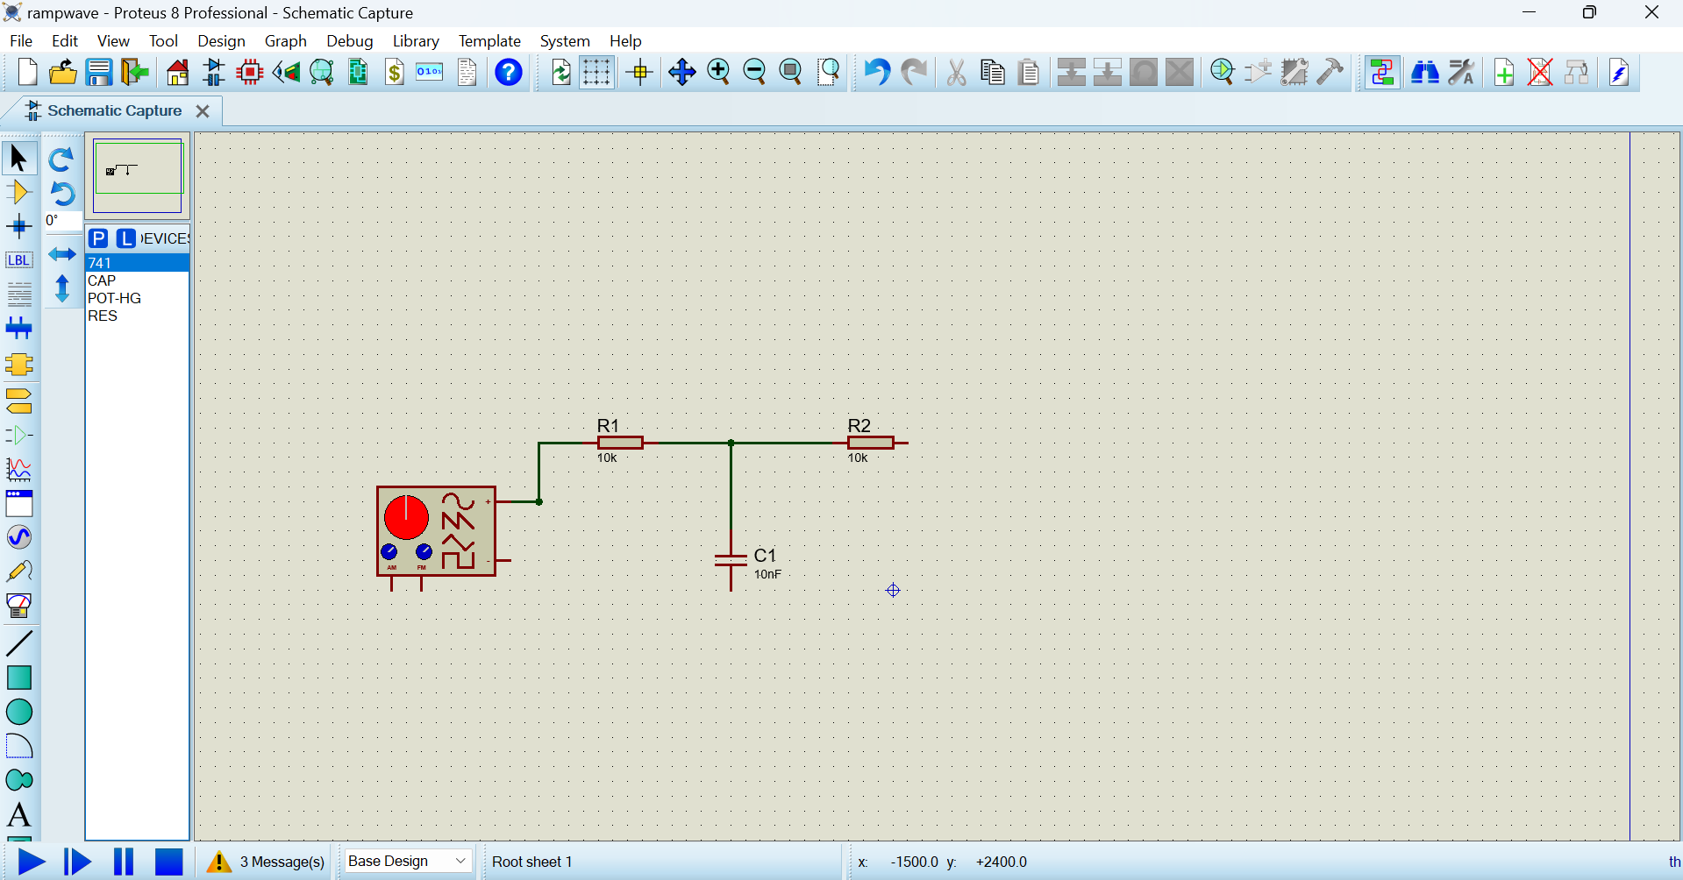

v. Select 741 from and place & connect as shown.
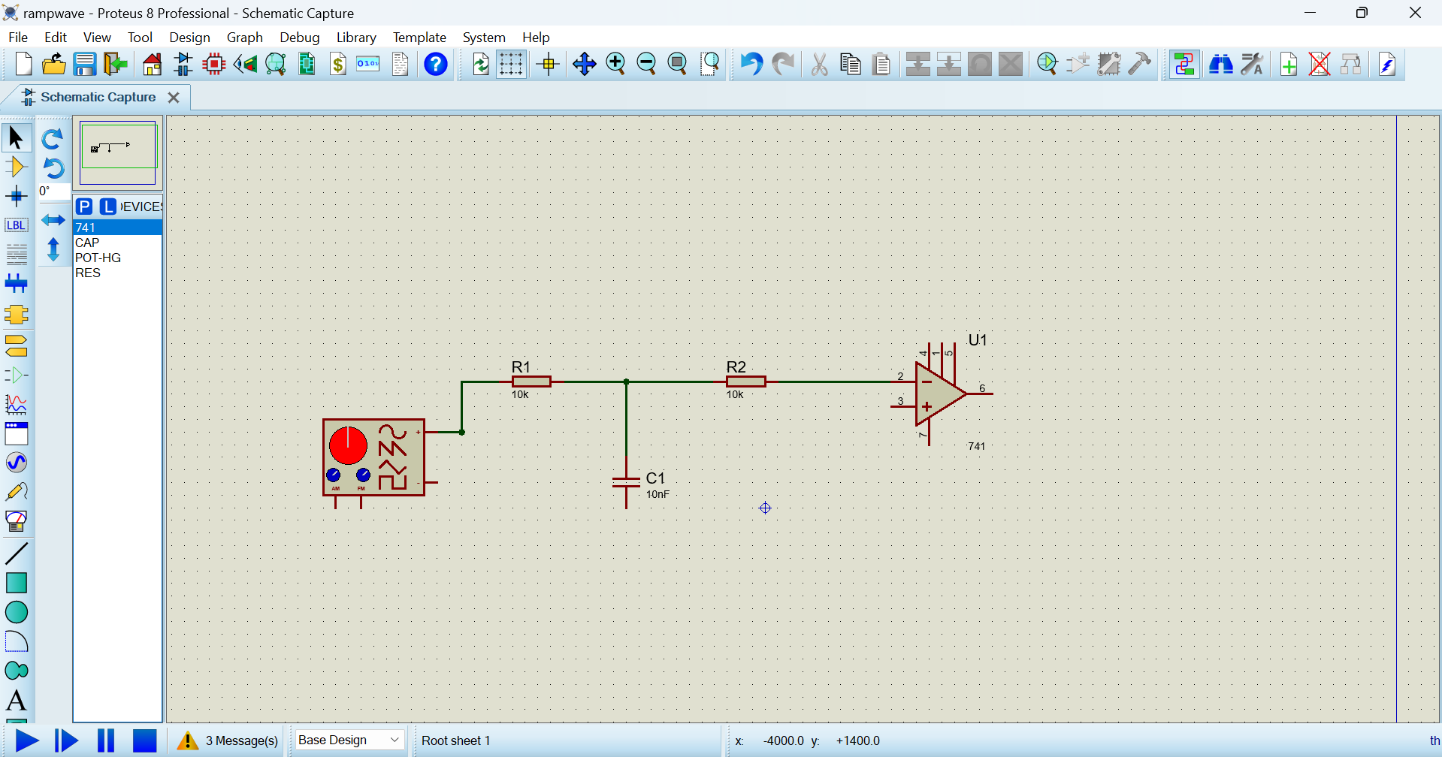

vi. Then do right click and select select GROUND from TERMINAL and place & connect as shown.
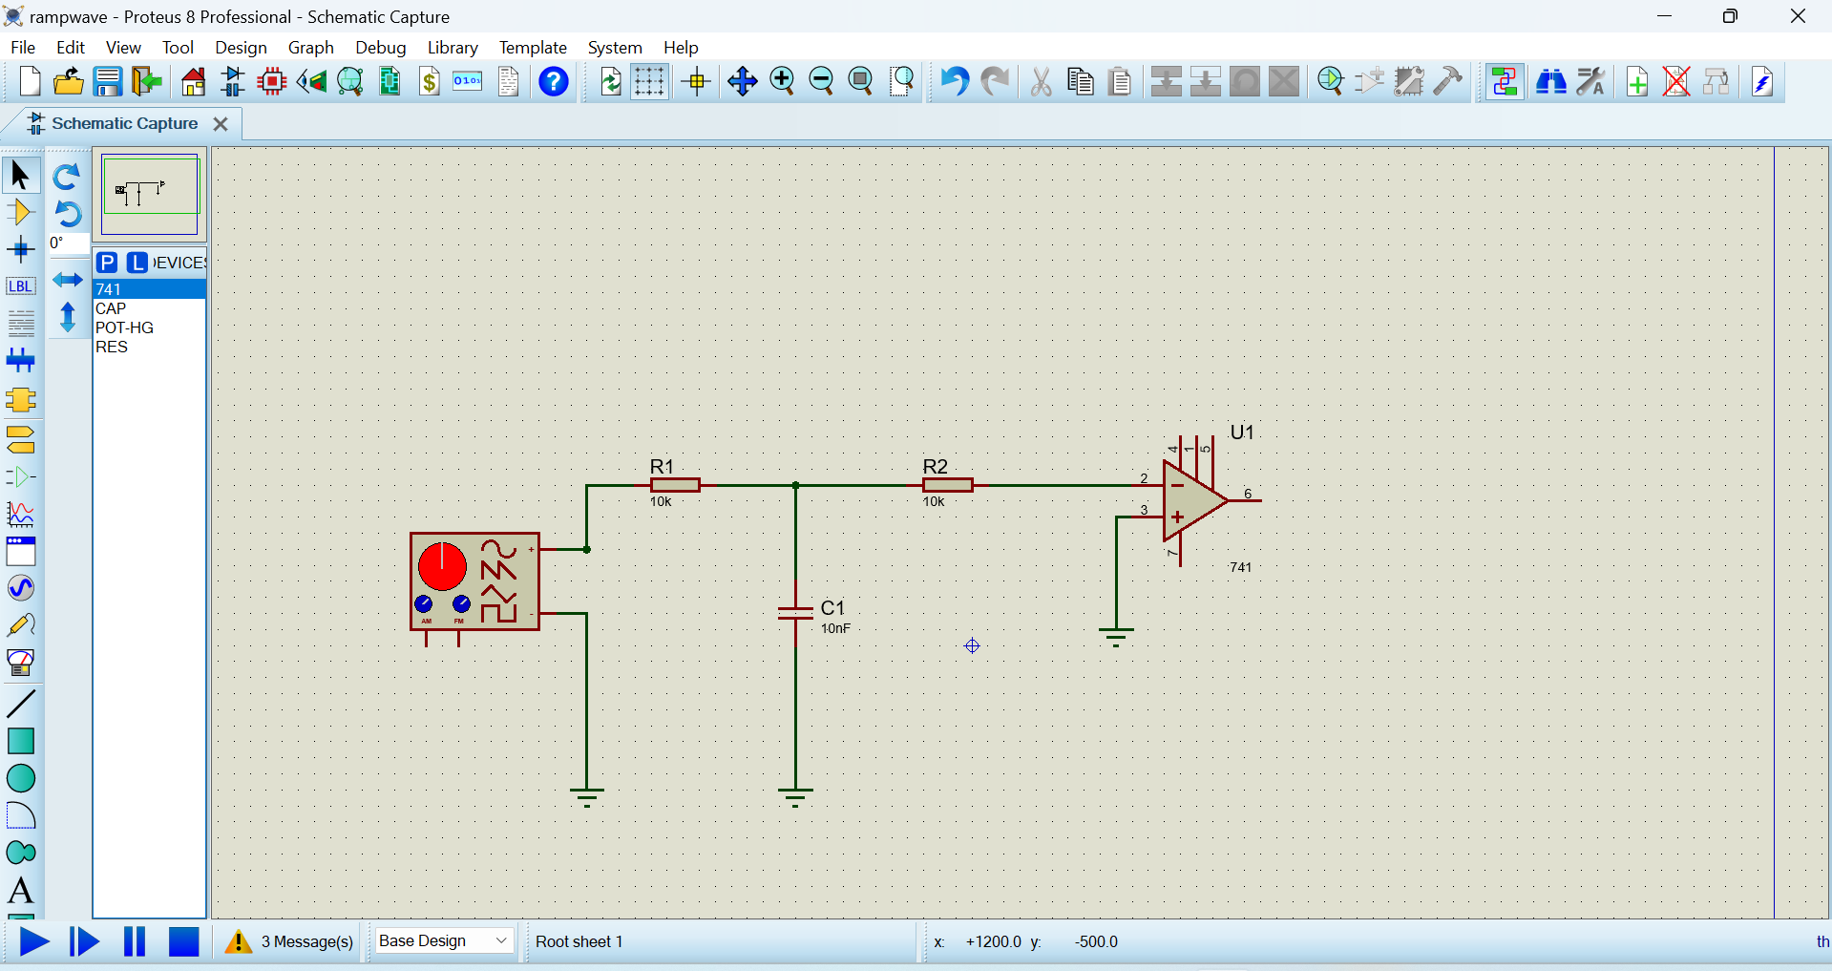

vii. Select DC from  and place & connect as shown and do double click and give –ve vale to –ve DC and +ve value to +ve DC.
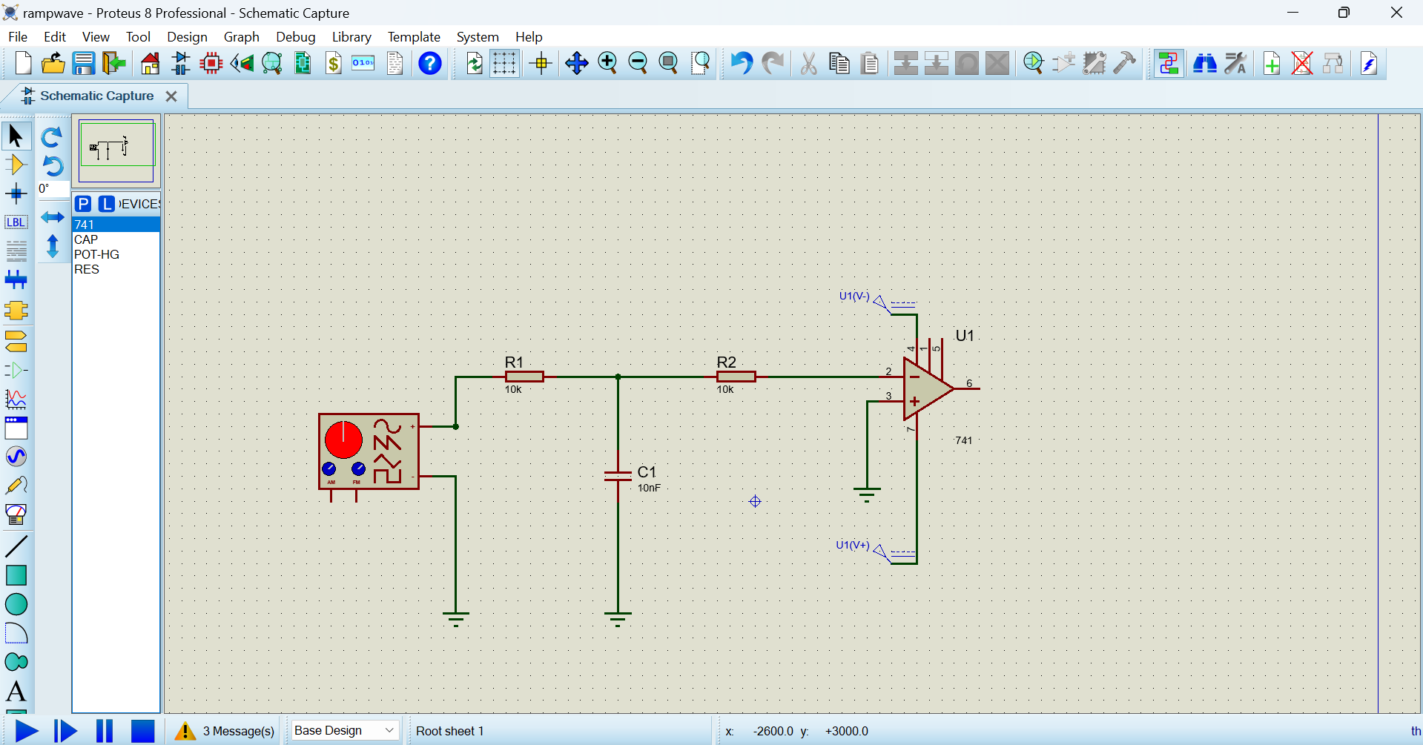

viii. Select resistor (POT-HG) from and place & connect as shown.
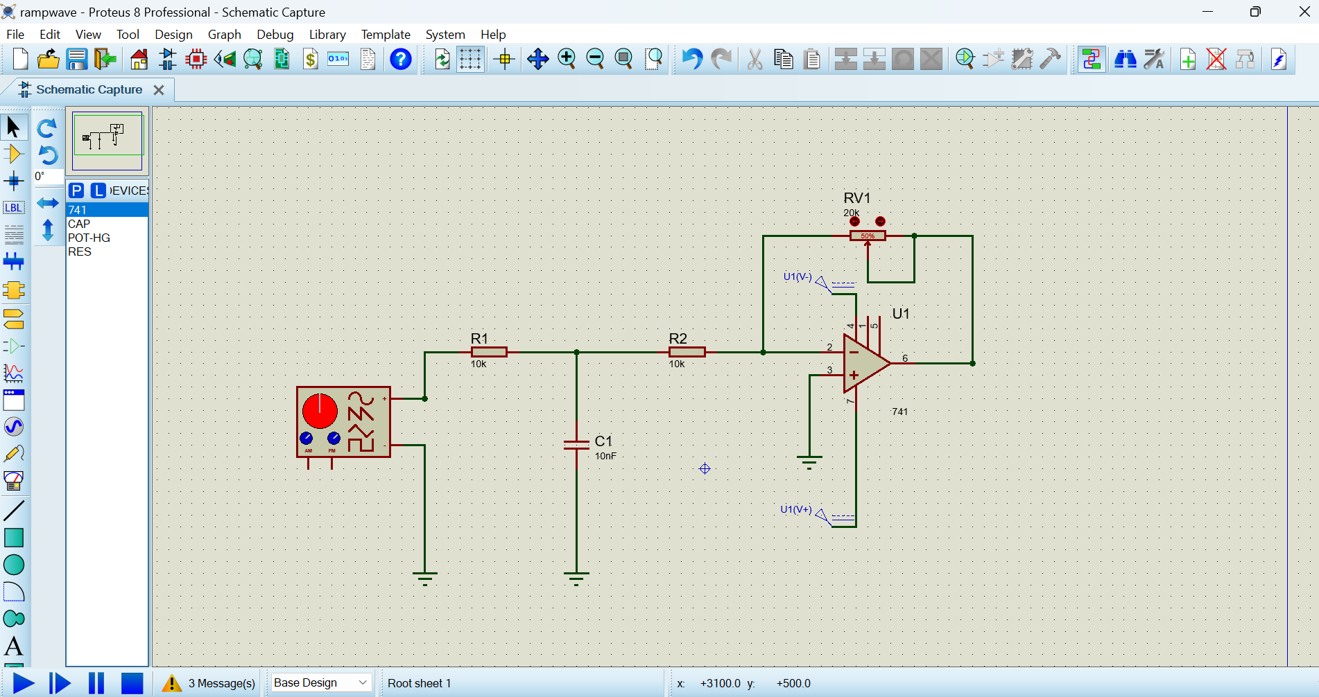

ix. Select OSCILLOSCOPE from and place & connect as shown.
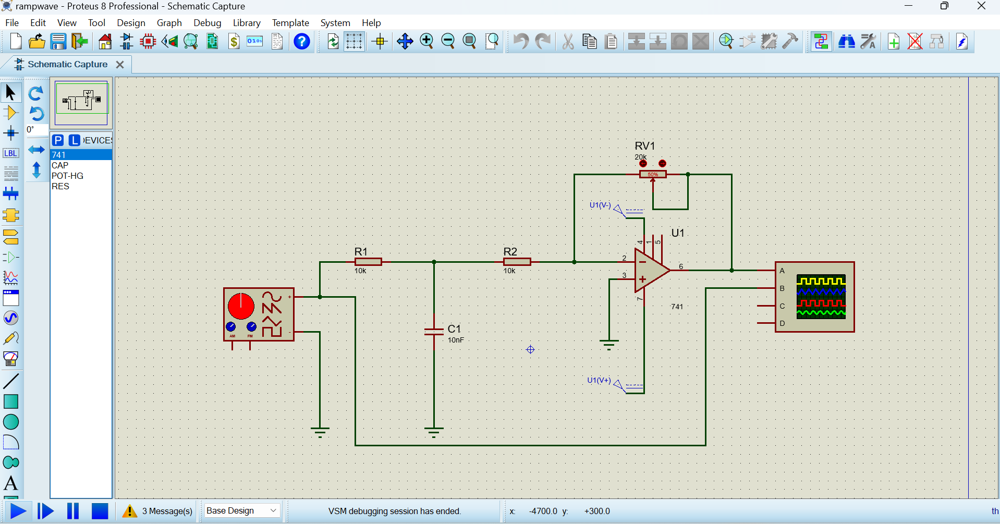
x. Select Run it using  Symbol and then select ramp wave in the signal generator and adjust the frequency accordingly to get the ramp wave as shown.
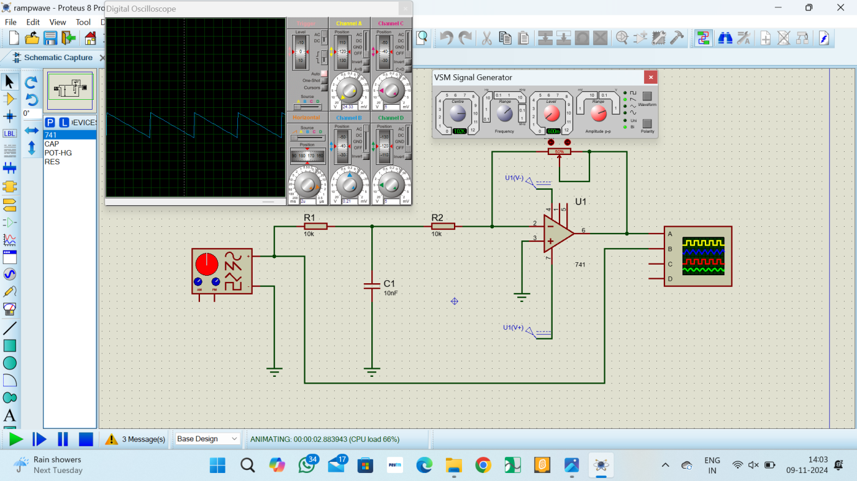
RESULT:
The ramp wave using Proteus is generated successfully.

